📘 Box Shadow – Asaan Samjhaav

📦 box-shadow kya karta hai?
box-shadow se kisi bhi box, button, image, div ke aas paas ek shadow (saaya) ban jata hai — jisse wo 3D ya utha hua lagta hai.
Jaise mobile mein WhatsApp msg box thoda utha hua lagta hai — wahi effect.

📏 Syntax yaad rakho:
box-shadow: X Y Blur Color;
Part | Kya hota hai?
X (horizontal) | Shadow left/right kitni ho ➡️
Y (vertical) | Shadow up/down kitni ho ⬇️
Blur | Shadow kitna soft ho 🌫️
Color | Shadow ka rang 🎨

✅ 5 Examples with Explanation

🔹 Example 1: Basic Grey Shadow
box-shadow: 5px 5px 20px gray;
📌 Matlab:
- Shadow right 5px aur bottom 5px
- Thoda blur (20px)
- Grey color
📷 Looks like: Box ke niche halka sa saaya
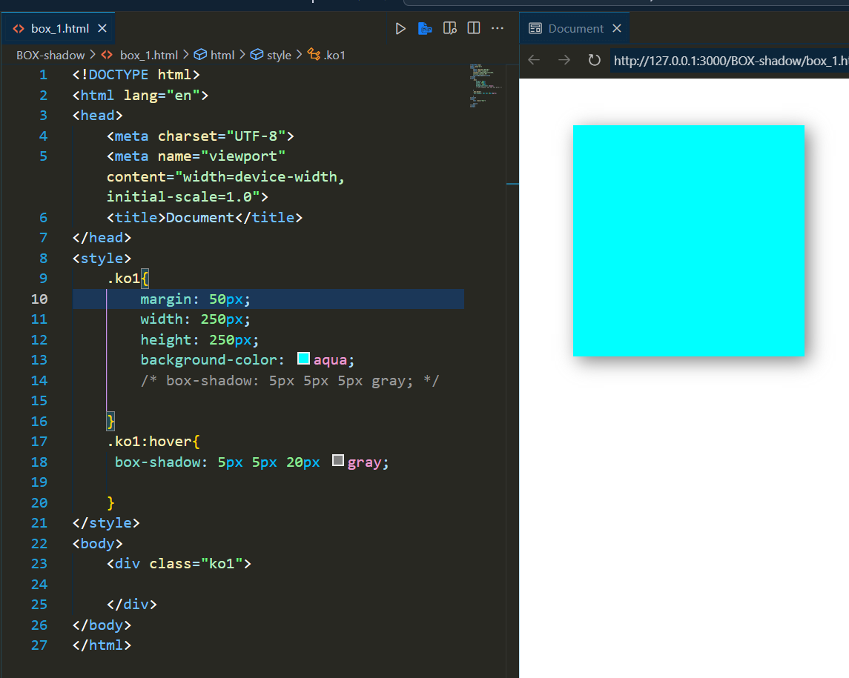

🔹 Example 2: Zyada Blur
box-shadow: 5px 50px 20px gray;
📌 Matlab:
- Same direction
- Zyada blur (20px) → aur soft shadow
- Grey color
📷 Looks like: Shadow aur wide ho gaya, zyada smooth
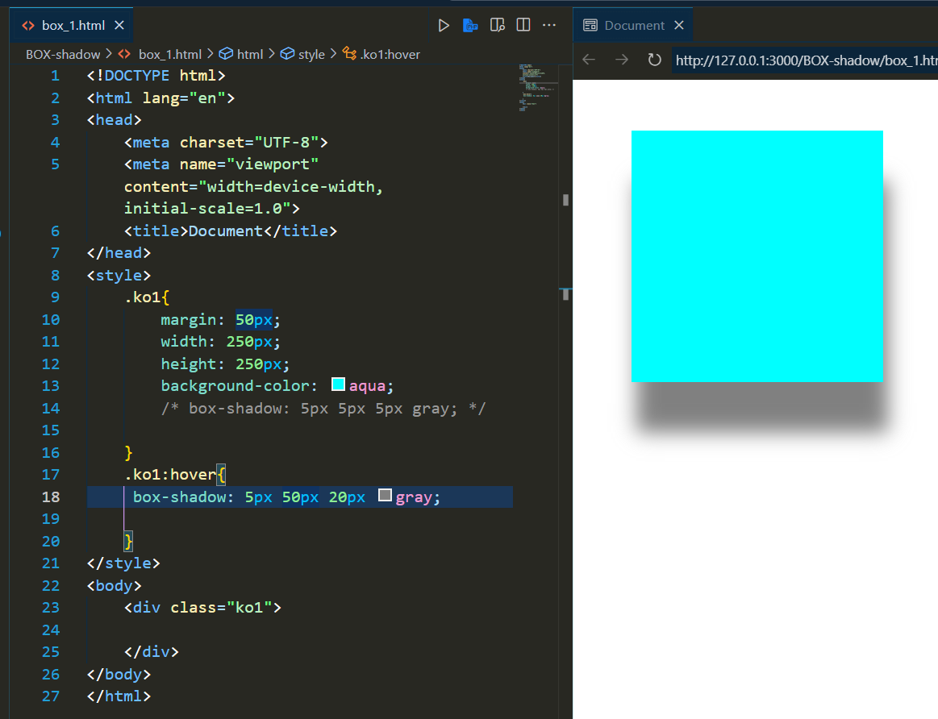

🔹 Example 3: Red Bold Shadow
box-shadow: 5px 10px 20px red;
📌 Matlab:
- Shadow same jagah
- Color red → 👀 bold & visible
📷 Looks like: Box ke neeche red glow jaisa effect
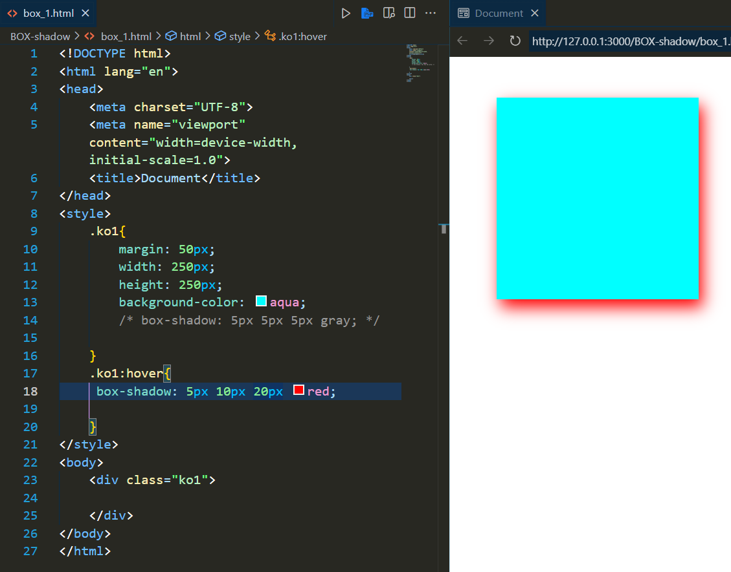

🔹 Example 4: Inner Shadow (Andar wala effect)
box-shadow: inset 0px 0px 10px black;
📌 Matlab:
- inset → shadow andar dikh rahi hai
- Black color
- 10px blur
📷 Looks like: Jaise box andar dab gaya ho (inner depth)
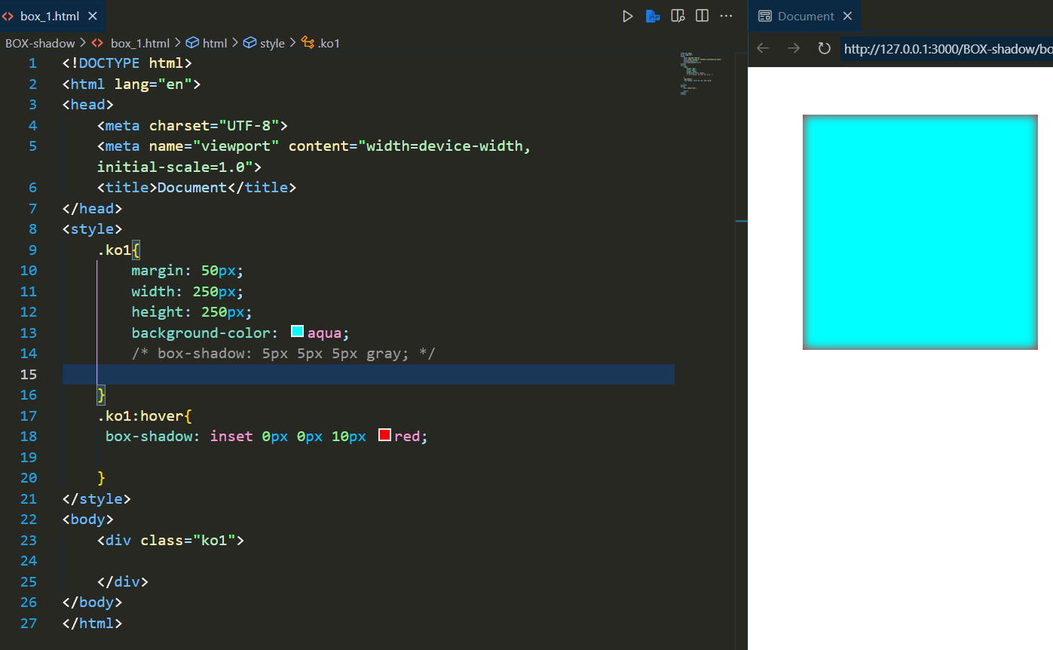
2
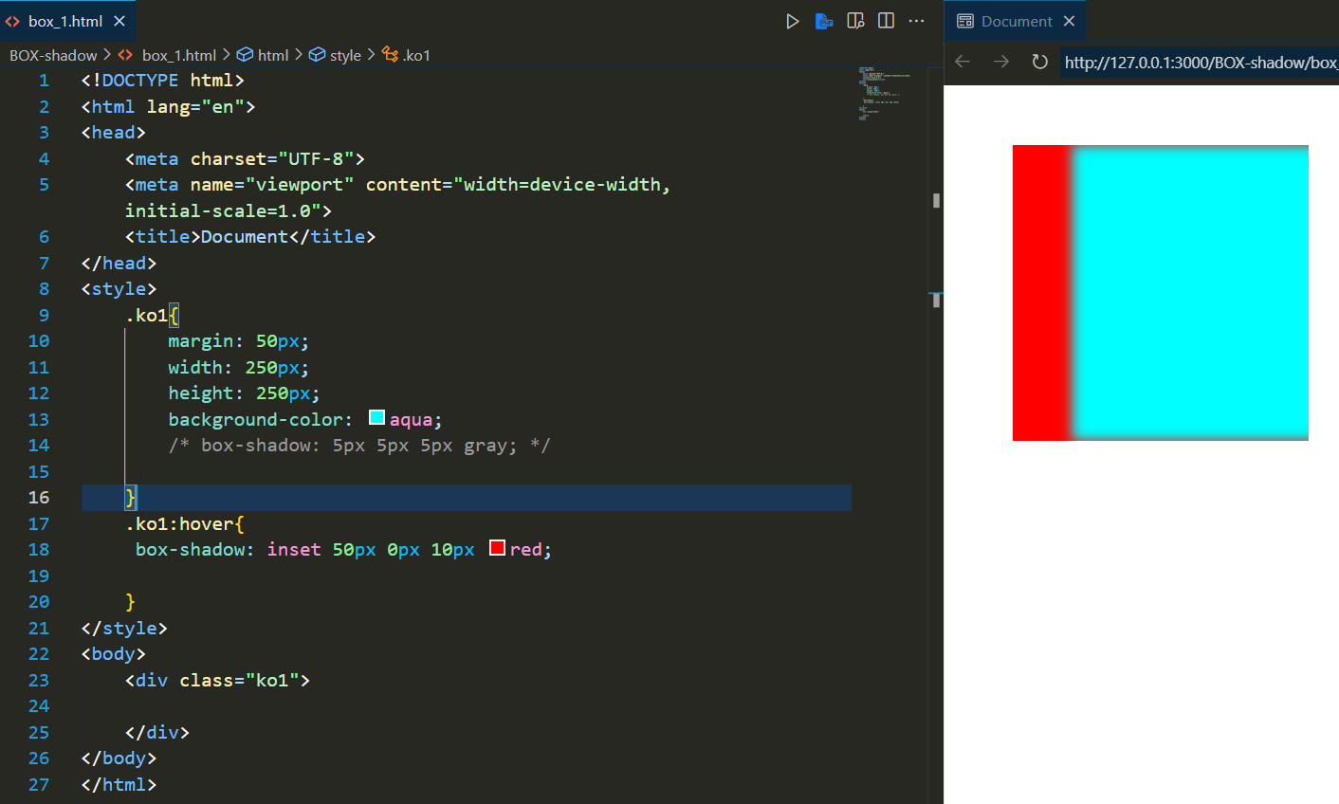
3 ->
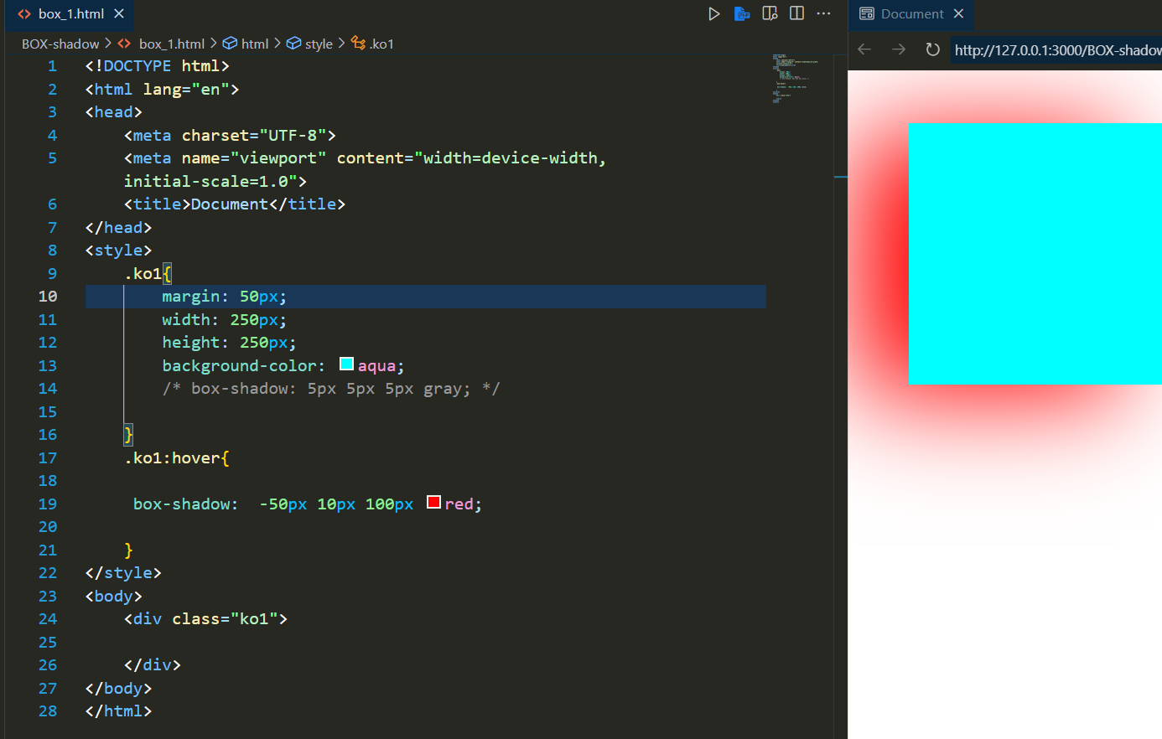

🔹 Example 5: Multi-shadow Combo
box-shadow: 3px 3px 10px blue, -3px -3px 10px pink;
📌 Matlab:
- Ek shadow right-bottom (blue)
- Dusri left-top (pink)
- Cool modern 3D effect
📷 Looks like: 2 direction se shadow aa rahi ho — glow feel
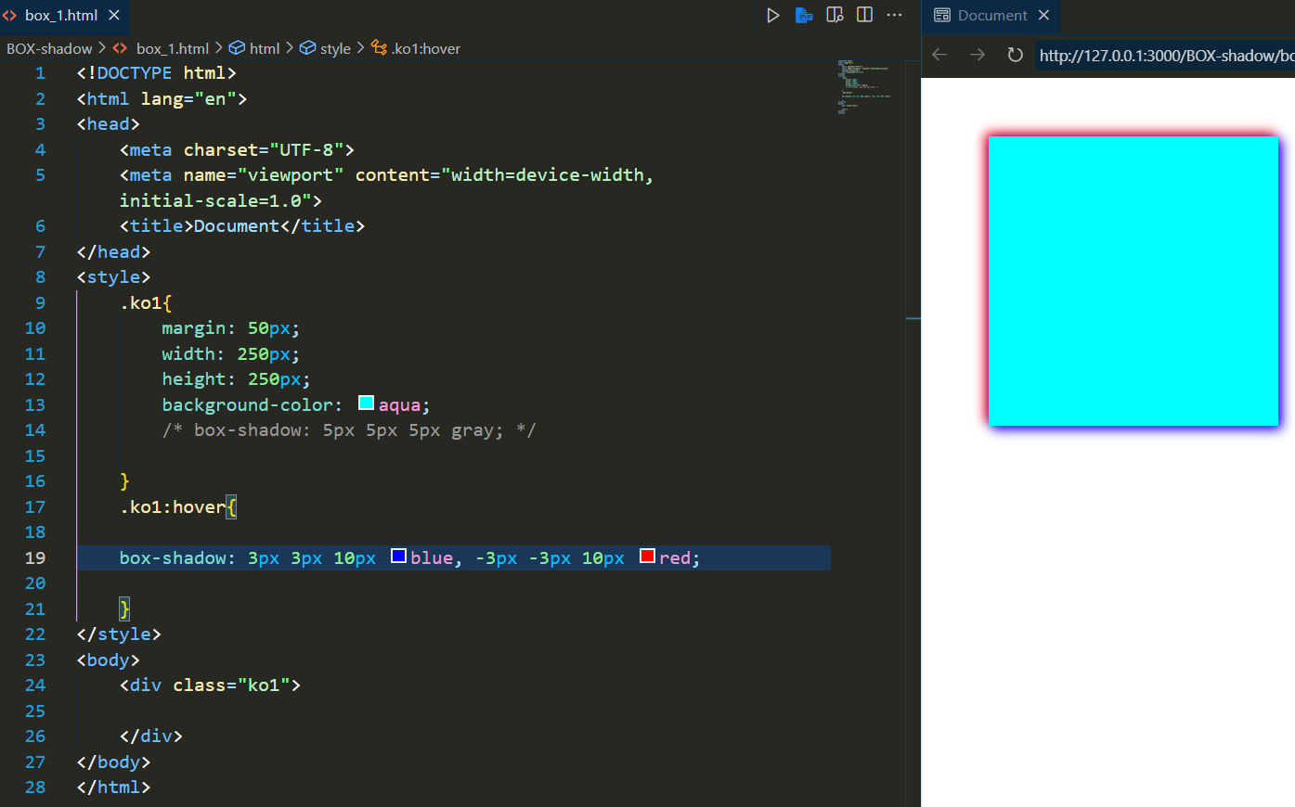
Multiple Shadow :
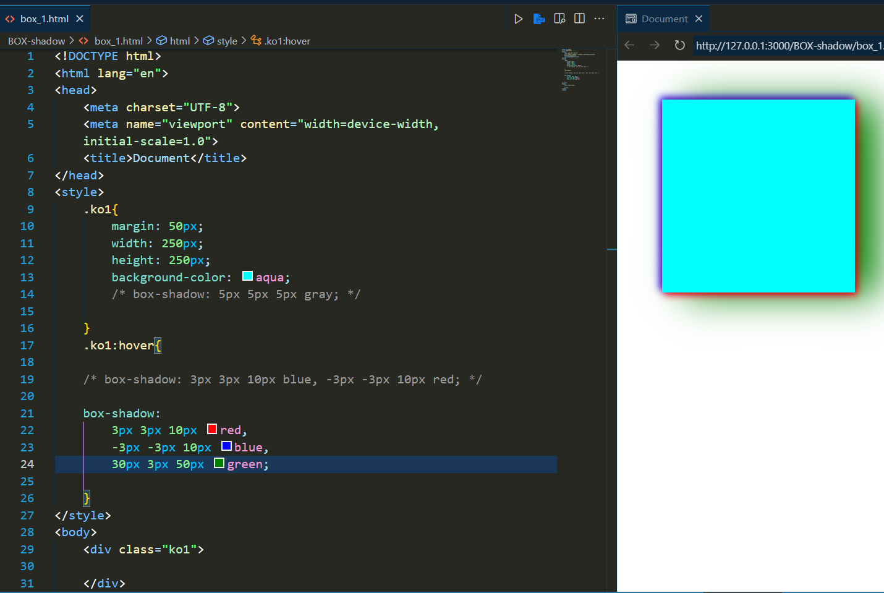

🎯 Final Note (In WhatsApp Style):
- box-shadow → Stylish bana deta hai box ko 😍
- Blur zyada = shadow soft
- Color se mood set karo 🔥
- inset = andar ka effect
- Multiple shadows bhi bana sakte ho ✌️

